Step 1. Create a personal account on the RF Public Services Portal .
Enter https://www.gosuslugi.ru/. Press “Личный кабинет”.
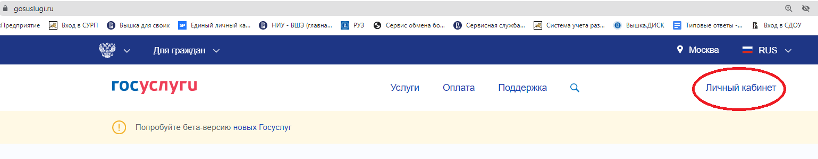
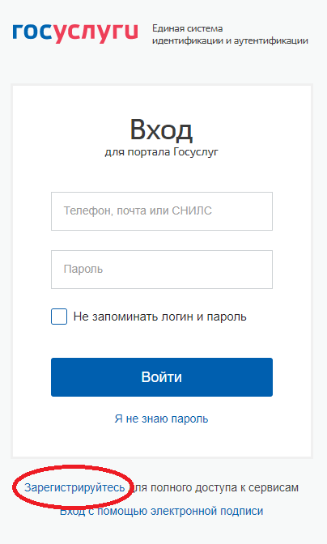
Fill out the registration
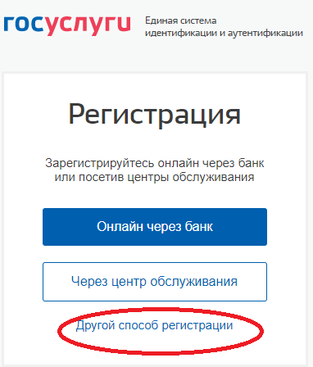
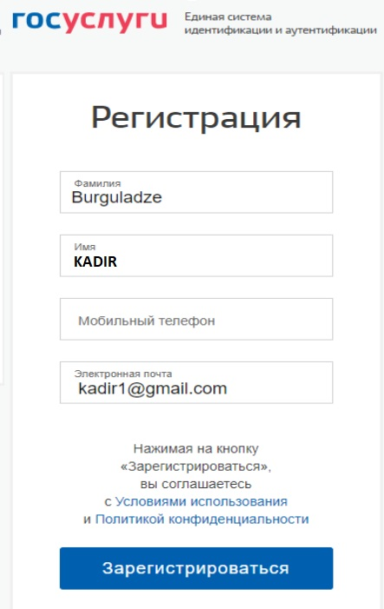

Step 2.

Confirm the registration.
Activate the link in e-mail from the portal

Step 3. Search your data
Enter the portal https://www.gosuslugi.ru/ Enter the personal account
Serch in the list of the services “Информация о включении в список для пересечения границы”
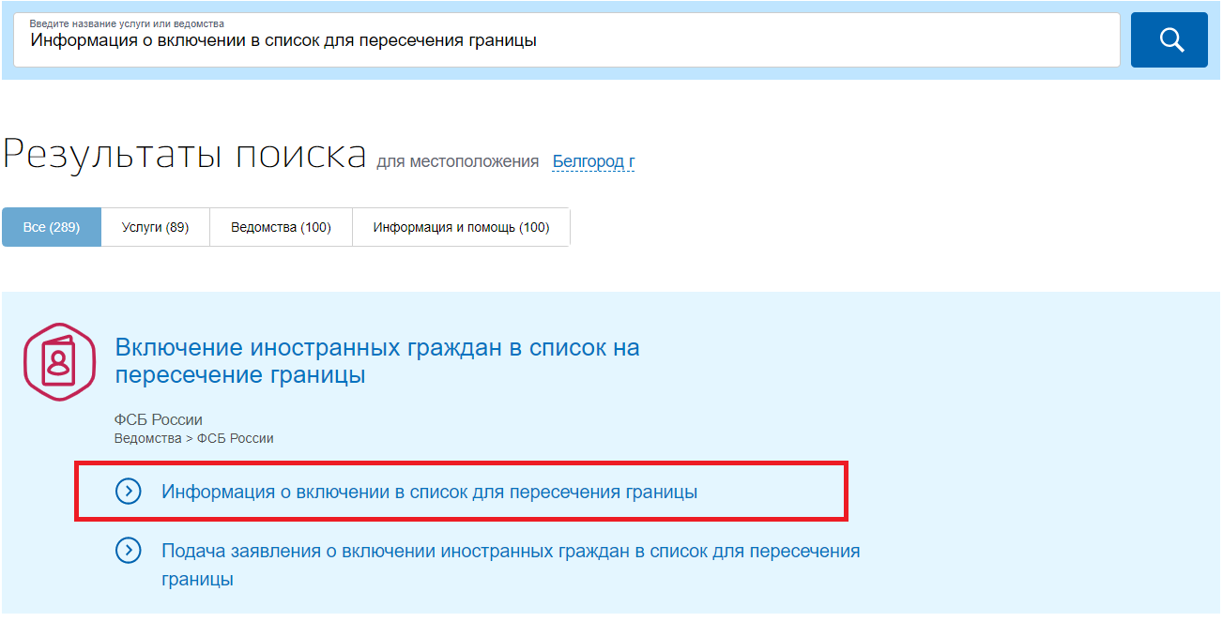

Get the service
Fill out the surname and name in Latin capital letters according to your passport data (firstly surname, then name) and number of the passport/document.
Search your data in the boarding list.
